These were South Africa’s most popular cars of 2022
Question/Vraag 1.3
New car sales are a measurement of the wealth of the local economy. Things are looking up as cars and commercial vehicles zoomed out of showrooms in 2022.
The 528 963 cars sold, was a 13.9% increase on 2021 and just 1.4% below the pre-pandemic 536 612 units sold in 2019. The strong performance took place, despite global shortages.
The KwaZulu-Natal floods forced market front-runner Toyota to shut its Durban car factory for four months. The production of best-selling models such as the Hilux, Corolla Cross and HiAce was on hold. But the carmaker weathered the storm with strong sales of imported models such as the Urban Cruiser, Starlet and Agya to keep its position as South Africa's most popular motoring brand.
Toyota managed to grow its sales 12.22% year-on-year. At 132 035 units it ended the year with nearly double the sales of its closest competitor, Volkswagen, with a 13.2% market share.
The Hilux continued its reign as South Africa's best-selling cars ahead of the Volkswagen Polo Vivo. While the Polo hatchback was overtaken by the Suzuki Swift, Toyota Urban Cruiser and Toyota Corolla Cross.
Ford's Ranger was in runout stage as the Silverton factory tooled up to start building its replacement. The one-tonner still shifted 17 341 units to make it the third best-selling car. Other popular bakkies were the locally-built Isuzu D-Max, Nissan NP200 and Nissan Navara.
In 2022 Mahindra grew its sale volumes by 78% compared with the previous year, making it South Africa's fastest-growing automotive brand.
Another carmaker that experienced strong year-on-year growth was Suzuki (71.04%), which moved the firm from sixth to third most popular brand.
Renault registered a jump of 29.61% and grew its market share to 5.15%. The French is sixth in the most popular brand rankings for 2022. Volkswagen was the only brand in the top 10 to record less sales than the year before.
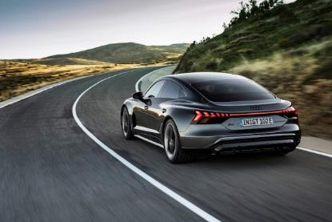
Chinese carmakers continued their impressive growth with Haval leading the way on 22 644 units. Making it the ninth most popular brand with a 4.28% market share. GWM's Steed and P-Series bakkies also remained popular. Both ranges shifted more than 4000 units. Returning Chinese brand Chery recorded an impressive 8 013 units in the second half of 2022.
Electric-car sales rose 132% off a very low base to 506 units (from 2018 in 2021). The launch of new battery-powered models from Audi, BMW, Mercedes-Benz and Volvo was introduced.

South Africa's 10 best-selling car brands of 2022
Car brand | Units sold | %Value
Ford | 26 335 | -15.40%
Haval | 22 644 | 18.80%
Hyundai | 36 047 | 7.70%
Isuzu | 21 274 | 7.00%
Kia | 22 766 | 12.90%
Nissan | 30 487 | 1.00%
Renault | 27 251 | 29.60%
Suzuki | 47 178 | 71.00%
Toyota | 132 035 | 12.20%
Minimum %Value
Volkswagen 69 801 -2.50%
Data from the National Association of Automobile Manufacturers of South Africa (NAAMSA) shows that South Africa's new car market continues to be on an upward course. Sales in 2022, was running 13.6% ahead of the corresponding period in 2021.
Over the course of the year, from January to November 2022, the car industry has sold almost half a million new cars. Selling a total of 487 699 units in 2022 with one month left in the year. The month with the most sales was March, with a total of 50 607 units sold.
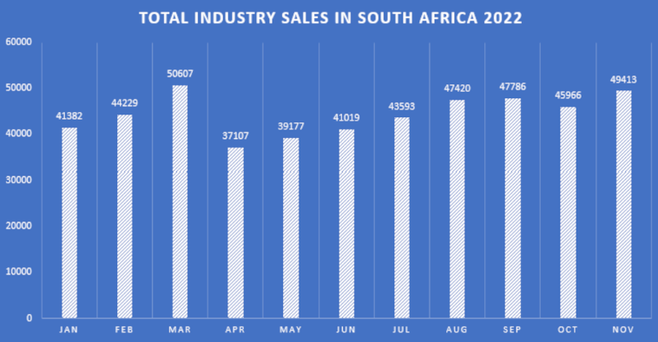
Graph 1: Industrial sales
Toyota reigns as the leading manufacturer of local car sales in 2022 by some margin. With 120 805 cars sold by the end of November. This represents 24.7% of the total number of new cars sold in South Africa this year.
Volkswagen Group is second with 64 470 cars sold locally. And Suzuki Auto ranks third with 44 120 units sold, representing 13.2% and 9% of the total number of new cars sold in South Africa this year, respectively.
The graph below shows the top five most popular car brands by sales in South Africa in 2022.
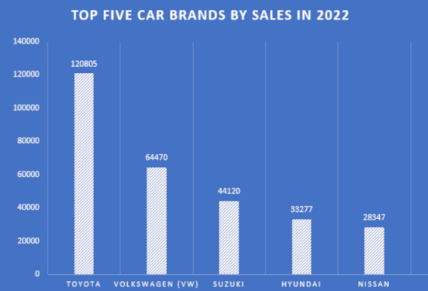
Toyota's success is partly due to the popularity of its flagship Hilux bakkie. Naturally, Toyota holds four positions on this list of the best-selling cars in 2022. The Toyota Hilux in the first position, followed by the Toyota Urban Cruiser in third, the Toyota Corolla Cross in eighth, and the Toyota Starlet in the tenth position.
Expectations for new car sales in 2023
Despite the positive numbers for car manufacturers in 2022, the new car market's strong performance is decelerating due to repeating increases in interest rates since November 2021. NAAMSA and car retailer Combined Motor Holdings (CMH) expect this to burden car sales.
"Growth forecasts for the year's balance remain constrained, as higher interest rates following higher debt servicing costs, weigh on disposable income. As a consequence, single-digit growth in new car sales could be expected for 2023" said NAAMSA.
New data from TransUnion’s Car Pricing Index (VPI) shows that prices of new cars have increased year-on-year. Economists point to the significant decrease of the rand over the course of 2022 as the culprit for the sharp increase in new car prices.
CMH went even further to say that it expects new car prices to increase by up to 10% within the next four months.
Nevertheless, the new car market continued to outperform expectations and with only one month to the end of the year, it was running 13.6% ahead of the corresponding period in 2021.
With several new model introductions over the past month, growth prospects for local car exports remain optimistic over the medium term, NAAMSA said.
The top 10 best-selling cars in South Africa in 2022 are listed below.
Car brand/model | Image | Units sold | Starting price
1. Toyota Hilux | 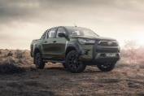 | 29 647 | R313 300
2. VW Polo Vivo | 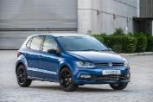 | 19 445 | R243 600
3. Toyota Urban Cruiser | 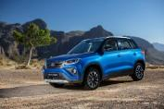 | 16 047 | R280 400
4. Isuzu D-max | 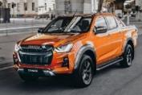 | 15 879 | R34 000
5. Ford Ranger | 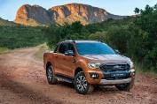 | 15 837 | R349 390
6. Suzuki Swift | 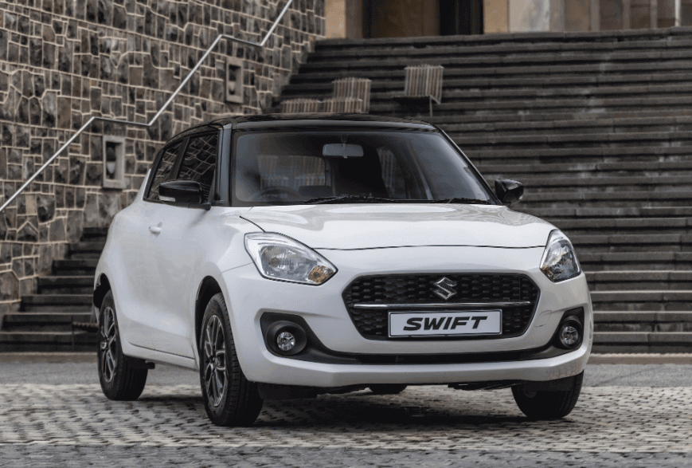 | 15 277 | R194 900
7. VW Polo | 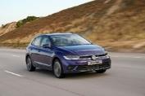 | 14 332 | R329 300
8. Toyota Corolla Cross | 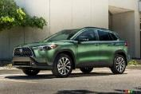 | 14 021 | R360 400
9. Nissan NP200 | 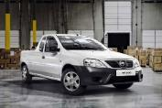 | 12 141 | R212 500
10. Toyota Starlet | 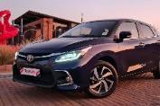 | 11 885 | R226 200
Adapted from source: https://www.timeslive.co.za/motoring/news/2023-01-26-these-were-south-africas-most-popular-cars-of-2022/

